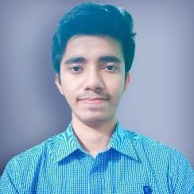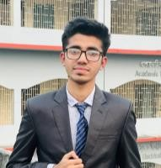

**Shovon Kumar Ray**

Father’s name: Dulal Chandra Ray

Mother’s name: Moushumi Ray

Road no-14, Block-A, Khilgaon, Dhaka-1219

01849944881 Email: [roydipto433@gmail.com](mailto:roydipto433@gmail.com)

# Academic Details

## Rajshahi University of Engineering and Technology (RUET)

B.Sc Engineering in EEE, Not yet Published , Pursuing

## Notre Dame College

HSC, GPA5, 89.23% scholarship Dhaka board 39th, 2019

## Khilgaon Govt. High School

SSC ,GPA5, 93.34%,Scholarship thana 1st of Dhaka board, 2017

# Field of Interest

Paintìng, Reading books, playing guitar, art, music, alpona Design etc

# Skills

AI developer, MS word,PowerPoint, multisim Machine learning(python) ,Matlab,Jupyter Notebook,HTML ,Artificial Intelligence expert etc

# Strength

Artificial Intelligence. Writing(published manytimes at college article), Creative thinking, Public Speaking etc

# Language proficiency

Bangla , English, Hindi, German

# accomplishment

Project: smart Vacuum cleaner(Arduino based),Fastest blood management(juypter notebook), solar energy based abstruct (secured semi final of Hult prize)etc

Hobby>Travelling, photography, video editing,gardening, singing,debating, Reciting Holy Geeta etc

**Extra co curcullar** Top ten(7th) at physics(2020),Finalist in chemisty(2023) olympiad by at Nuclear power plant rooppur org by precise energy,Russia,talent hunt school level (2015),Semi finalist at Hult prize RUET,

Art competition at school level.

# contribution

Co Ordinator of English Olympiad, campus ambassador(CA) international MUN,certified CA of IIT software Engineers society,worked as Joint Secretery(org) of Sarbjnin Puja Ujjapn Parisod,Campus ambassador of Gonitjoggo(natinal Math Olympiad BD) etc



(Shovon Kumar Ray )